**ST.LAWRENCE  UNIVERSITY**

**FACULTY OF COMPUTER AND INFORMATION TECHONOLOGY**



|  |  |
| --- | --- |
|  | ***PHP EXAM*** |

W

LECTURER: **Kevin Javier**

***TOPIC:***

***Medical Store Management System using PHP***

**PRESENTED BY:**

**-**

Muyisa Patayo Clemence (***BAIT/C/14A/D/292)***

. YEAR**: TWO**

**.** SEMESTER**: ONE**

**ACADEMIC YEAR: 2015 – 2016**

**Acknowledgement**

In general I would like to say thanks to God for always being with me since we start this semester.

In particular way, I say thanks to Mr Kevin Javier, who take me through this course and taught me all the knowledge I have about programming using Php.

I will not forget to say thanks to all my classmates, they have explained to me all other things, I was not getting when the lecturer taught them in class.

Thank you to all my friends.

**MEDICAL STORE MANAGEMENT SYSTEM**

**Clemence Medical Store**

Designed by:

Muyisa Patayo Clemence

BAIT/C/14A/D/292

On 29th November 2015

TABLE OF Contents

**topic………………………………………………………………………………**

**table of contents………….……………………………………………….**

**introduction……………………………………….…………..……………..**

**Brief background…………………………………………………………...**

**statement of problem…………………………………………………….**

**objective……………………………………………………………..………….**

**scope of the study…………………………………………………………..**

**model of the system using entity relational (e-r)…………..**

**implementation code………………………………………………………**

**short screens of the system……………………………………………**

**CHALLENGES and the benefits……………………………………………**

**conclusion……………………………………………………………………….**

INTRODUCTION

The goal of any system development is to develop and implement the system cost effectively; user-friendly and most suited to the user’s analysis is the heart of the process. Analysis is the study of the various operations performed by the system and their relationship within and outside of the system. During analysis, data collected on the files, decision points and transactions handled by the present system. Different kinds of tools are used in analysis of which interview is a common one.

After hearing about the project we had to give, I had the ideas of an hospital at first but after consulting the web, I so that hospital management system are to many in the world, I say to myself, cause I want to stay in the mood or world of hospital, what is I build a store that can keep medicines for hospital and some big pharmacies in the world? So I started to remember the way that in some hospital in my country and the big store in my town sometime get problem of lost cause they forget to register what medicines is entered and retrieve from their store. That why after viewing all those problems, I decide to build a **Medical Store Management System to** help in solving this kind of problems.

I decided to give that store my name “**Clemence Medical Store**” since I don’t know from now the correct name of the main medical store in my town.

After having all the information I needed, I started to work on my site but I said "which program am I going to use?"So I decided to use **sublime** text and **Dreamweaver** text editors**.**

**BRIEF BACKGROUND**

This Project is related to Hospital Management System. The project maintains two levels of users:

**•** Administrator Level.

• User Level-Data Entry Operator.

Main facilities available in this project are:-

• User login

• Storing new Hospital and pharmacies that want to keep their medicine in Clemence Medical Store.

• Retrieving or Removing medicine from the store .

• Editing the information in the database.

• Deleting the information in case the date of inspiration arrive when they still in the store.

• Searching a Hospital to know quickly the medicine it has in the store.

• Viewing all hospitals and pharmacies that have their medicines in the store.

• Logout from the system.

User or Administrator can search members ‘medicines by his/her name.

This store is a place where Hospitals and pharmacies come to store their medicines. So, some activities perform here are.

* Keep well medicines for hospitals and pharmacies that wish his services
* Sales some medicines for pharmacies if they give the store the right of doing that.
* Be aware of any new medicine that comes out everywhere in the world and tell his members about it.
* Alert a member when the date of expiration is about to arrive so that he or she can see how to sale or use that medicine before the date. If the date arrives and the medicine still in the store, the store has the right of deleting it in the database and destroy that medicine
* Pay a global tax for all his members to the government.
* Alert a member when such or such of his stock of medicine is about to finish and tell him to buy others or if it (hospital or pharmacy) give the right to the store to buy on its behave when such situation occurs, the store can pass the command for it.

**OBJECTIVE**

The main objective of our system is to help many hospitals and big pharmacies to find a places where they can keep well and be sure the medicines are secure, but also for the store to avoid losses and any sales of expired medicines to the population of any country or town in the world.

STATEMENTS OF THE PROBLEM

1. **Lack of immediate information storage**: The information generated by various transactions takes time and efforts to be stored at right place.
2. **Lack of prompt updating:** Various changes to information like medicines details or immunization details of a new medicine are difficult to make as paper work is involved.
3. **Lack of immediate retrievals**: The information is very difficult to retrieve and to find particular information like. E.g. To find out about the medicine’s history, the user has to go through various registers. This results in inconvenience and wastage of time.

SCOPE OF THE STUDY

It can be used in any medical store in the world. The sture or scope we used is this

* The Website contain 5 WebPages HTML and 6 PHP
* Navigation Scheme: Global navigation
* Website Dimensions
* Font size
* Database: MySQL
* Softwares used: sublime text and Dreamweaver
* Login authentication
* Insertion of Data
* Retrieval of Data
* Research of data
* Delete and Edition data

**SYSTEM MODEL (ENTITY RELATIONAL MODE (E.R))**

**Index page**

Home

**Logout**

**Edit Stock**

**Remove Item**

**Add Item**

**Registration**

**Store sheet**

**Login**

**Contact**

**Blog**

**Welcome Page**

**About**

We are going to explain what each of those pages do in our system.

**Home page**, in/on this page we are just welcoming all visitors of our web site. Cause our work is a web site before being a system. And all the main pages are linked to this page. On this page, we have just put some pictures of some medicines and some words about the store, but also a place where visitors can leave us a message. It is what we have called again in the structure of our system “**Welcome page**”.

**About page**, in/on this page we just talk about Clemence Medical store, how it has started and some member whom owned it. We have put also links to all those main pages to let or allow the user to move quickly to other pages without no need to go back to the home page.

**Blog page**, in/on this page we just talk about some innovation Clemence Medical store have realized since it has started. Also all links to all other main pages are on this page.

**Contact page**, in/on this page, the most important thing is a space where a visitor can leave a message or suggestion. But also a map to find quickly the location of the store in case he wants to visit the physical store. We lease here even our telephone number and email address.

**Login page**, this page is just consecrate to the information of logging in the store information. Only the member of the store can access what is in the store through this page. Also we have a link to register new member. That link takes you to our 6th page called “**Registration page**”.

**Store Sheep page**, this page is just for display all item in the store. We have a search form to help in funding quickly medicines related to each member of the store.

**Add item page**, this page is just a form to let the user register new medicine that member bring in the store.

**Remove item page**, this page is just a form also to let the user to register all medicine that members can remove or retrieve from the store for sale or other purposes.

**Edit Stock page**, this page contains a form to allow the user to edit something in case he/ she has registered wrong details about a member information.

**Logout,** this link takes the user to the home page when he/she have finished all work with the store.

**IMPLEMENTATION OF CODES**

**Connection.php codes**

<?php

$servername="localhost";

$username="root";

$password="";

$databasename="medical_db";

$connect=mysql_connect($servername,$username,$password) or die("Unable to connect to The Server");

$select_db=mysql_select_db($databasename)or die("Unable to connect to The Server");

?>

**View codes**

<h1 align="center">Medical Store Sheet</h1>

<table width="1000" border="1" align="center">

<tr>

<td width="289"><strong> Hospital Name</strong></td>

<td width="214"><strong>Medecine Name</strong></td>

<td width="214"><strong>Quantity</strong></td>

<td width="214"><strong>Unit Price</strong></td>

<td width="214"><strong>Removed Quant</strong></td>

<td width="214"><strong>Removed Price</strong></td>

<td width="214"><strong>Price Entered Item</strong></td>

<td width="214"><strong>Total Price</strong></td>

<td width="57"><strong> ID </strong></td>

<td width="161"><strong> Actions </strong></td>

</tr>

<?php

include ("connection.php");

$strquery="SELECT * from store_tbl";

$results=mysql_query($strquery);

$num=mysql_num_rows($results);

$i=0;

while ($i< $num)

{

$name=mysql_result($results,$i,"name");

$mname=mysql_result($results,$i,"mname");

$quant=mysql_result($results,$i,"quantity");

$unit=mysql_result($results,$i,"uprice");

$balance=mysql_result($results,$i,"balance");

$bprice=mysql_result($results,$i,"bprice");

$rprice=mysql_result($results,$i,"rprice");

$tprice=mysql_result($results,$i,"tprice");

$id=mysql_result($results,$i,"id");

?>

<tr>

<td><?php echo $name ; ?></td>

<td><?php echo $mname ; ?></td>

<td><?php echo $quant ; ?></td>

<td><?php echo $unit ; ?></td>

<td><?php echo $balance ; ?></td>

<td><?php echo $bprice ; ?></td>

<td><?php echo $rprice ; ?></td>

<td><?php echo $tprice ; ?></td>

<td><?php echo $id ; ?></td>

<td><?php echo " <a href='edit.php?do=edit&id=" . $id . "'> edit </a> "; ?> | <?php echo " <a href='delete.php?id=" . $id . "'> delete </a> "; ?></td>

</tr>

<?php

$i++;

}

?>

<tr>

<td>&nbsp;</td>

<td>&nbsp;</td>

<td>&nbsp;</td>

<td>&nbsp;</td>

<td>&nbsp;</td>

<td>&nbsp;</td>

<td>&nbsp;</td>

<td>&nbsp;</td>

<td>&nbsp;</td>

<td>&nbsp;</td>

</tr>

</table>

**Search codes**

<?php

include ("connection.php");

$strquery = "SELECT * from store_tbl where name like '" . $_GET["search"] . "%' ";

$results = mysql_query ($strquery);

$row = mysql_fetch_array($results);

$num=mysql_numrows($results);

$i=0;

while ($i< $num)

{

$name=mysql_result($results,$i,"name");

$mname=mysql_result($results,$i,"mname");

$quant=mysql_result($results,$i,"quantity");

$unit=mysql_result($results,$i,"uprice");

$balance=mysql_result($results,$i,"balance");

$bprice=mysql_result($results,$i,"bprice");

$rprice=mysql_result($results,$i,"rprice");

$tprice=mysql_result($results,$i,"tprice");

$id=mysql_result($results,$i,"id");

?>

<tr>

<td><?php echo $name ; ?></td>

<td><?php echo $mname ; ?></td>

<td><?php echo $quant ; ?></td>

<td><?php echo $unit ; ?></td>

<td><?php echo $balance ; ?></td>

<td><?php echo $bprice ; ?></td>

<td><?php echo $rprice ; ?></td>

<td><?php echo $tprice ; ?></td>

<td><?php echo $id ; ?></td>

<td><?php echo " <a href='edit.php?do=edit&id=" . $id . "'> edit </a> "; ?> | <?php echo " <a href='delete.php?id=" . $id . "'> delete </a> "; ?></td>

</tr>

<?php

$i++;

}

?>

<tr>

<td>&nbsp;</td>

<td>&nbsp;</td>

<td>&nbsp;</td>

<td>&nbsp;</td>

<td>&nbsp;</td>

<td>&nbsp;</td>

<td>&nbsp;</td>

<td>&nbsp;</td>

<td>&nbsp;</td>

<td>&nbsp;</td>

</tr>

</table>

**Edit, update and delete codes**

* **Edit codes**

include ("connection.php");

$strquery = "SELECT * from store_tbl where id= '" . $_GET["id"] . "' ";

$results = mysql_query ($strquery);

$row = mysql_fetch_array($results);

?>

<div class="col-md-6">

<form id="add" name="add" method="get" action="update.php">

<table border="0" align="center">

<tr>

<td ><strong>Hospital Name:</strong></td>

<td ><input name="name" type="text" id="name" value="<?php echo $row["name"]; ?>"/></td>

</tr>

<tr>

<td>

<strong>

<label>Medicine Name</label></strong></td>

<td><input name="mname" type="text" id="mname" value="<?php echo $row["mname"]; ?>"/></td>

</tr>

<tr><td>

<strong>

<label>Quantity:</label></strong></td>

<td><input name="quantity" type="text" id="quantity" value="<?php echo $row["quantity"]; ?>"/></td>

</tr>

<tr><td>

<strong>

<label>Unit Price:</label></strong></td>

<td><input name="uprice" type="text" id="uprice" value="<?php echo $row["uprice"]; ?>"/></td>

</tr>

<tr>

<td ><strong>Item to Remove:</strong></td>

<td ><input name="balance" type="text" id="balance" value="<?php echo $row["balance"]; ?>"/></td>

</tr>

<tr>

<td>&nbsp;</td>

<td><input type="submit" name="Submit" value="Update" /></td>

</tr>

</table>

<label><br />

</label></form>

* **Update codes**

<?php

$slau=mysql_connect("localhost","root","");

mysql_select_db("medical_db",$slau);

$strquery="UPDATE store_tbl SET name= '" . $_GET['name'] . "', mname= '". $_GET['mname'] ."', quantity= '". $_GET['quantity'] ."', uprice= '". $_GET['uprice'] ."', balance= '". $_GET['balance'] ."' WHERE id='". $_GET['id'] ."' ";

$results=mysql_query ($strquery);

header ('location:view.php');

?>

* **Delete codes**

<?php

include ("connection.php");

// $connect=mysql_connect($servername,$username,$password);

// $select_db=mysql_select_db($databasename);

$strquery="DELETE from store_tbl where id = '" . $_GET['id'] . "' ";

$results=mysql_query ($strquery);

echo 'Delete Successfull!!<br/><a href="index.php">Go Back to the Main Page <a>';

header ('location: view.php');

?>

**Logout codes**

<?php

session_start();

if(!isset($_SESSION['id']))

{

header("Location: index.html");

}

else if(isset($_SESSION['id'])!="")

{

header("Location: about.php");

}

if(isset($_GET['logout']))

{

session_destroy();

unset($_SESSION['id']);

header("Location: index.html");

}

?>

**SOME SCREEN SHORT OF THE SYSTEM**

**Home page**

 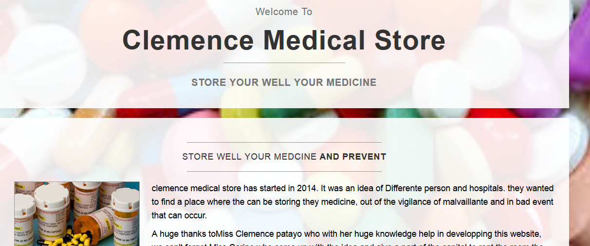 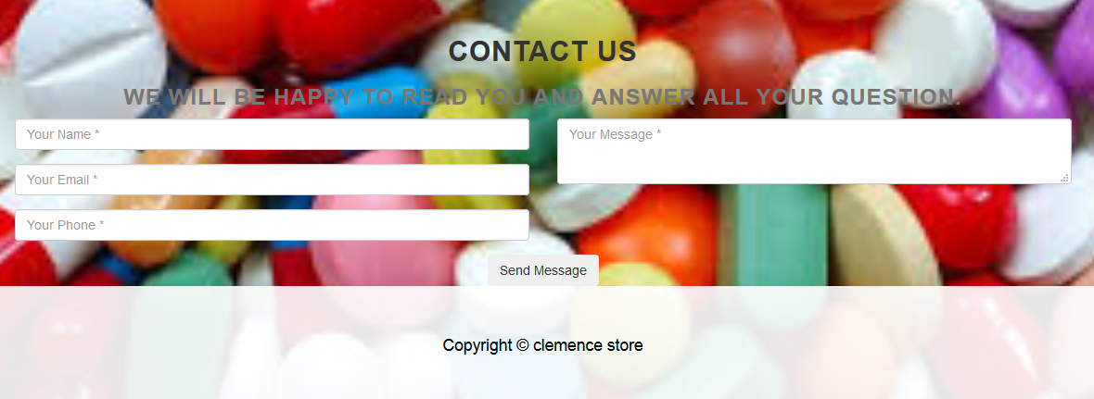

**User Login**

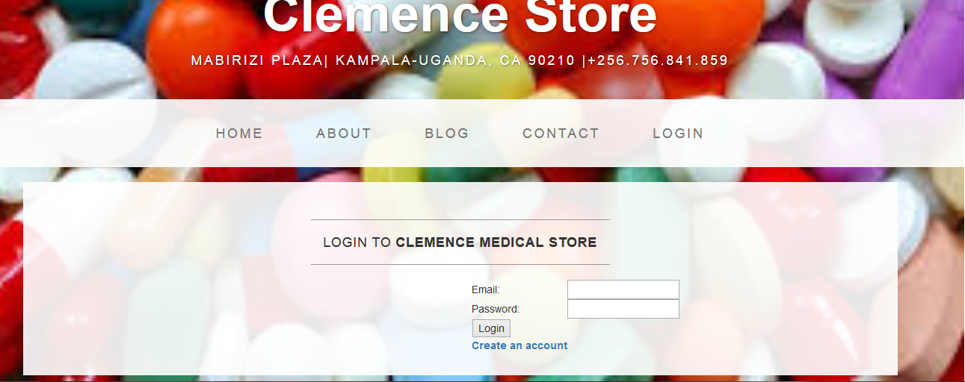

**Registration page for new members**

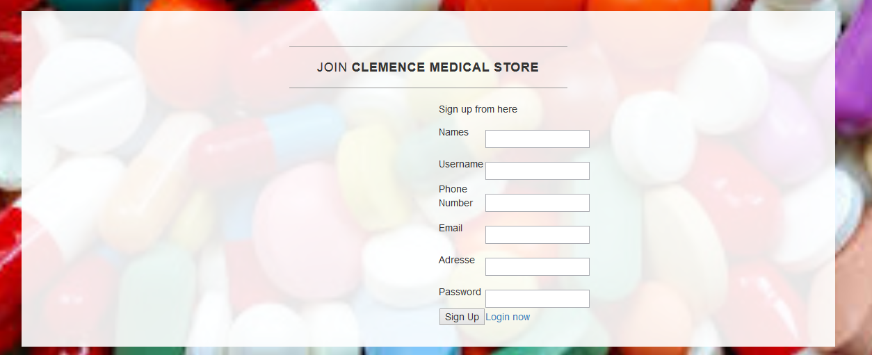

**Add Item to Clemence Medical Store**

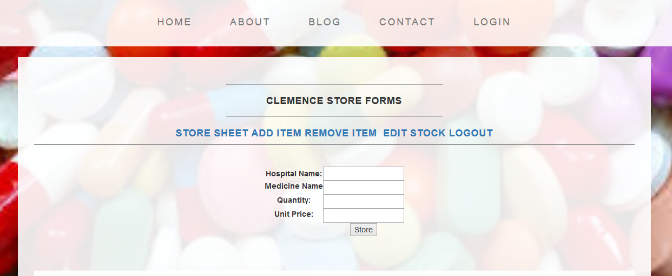

**Store Sheet of Clemence medical Store**

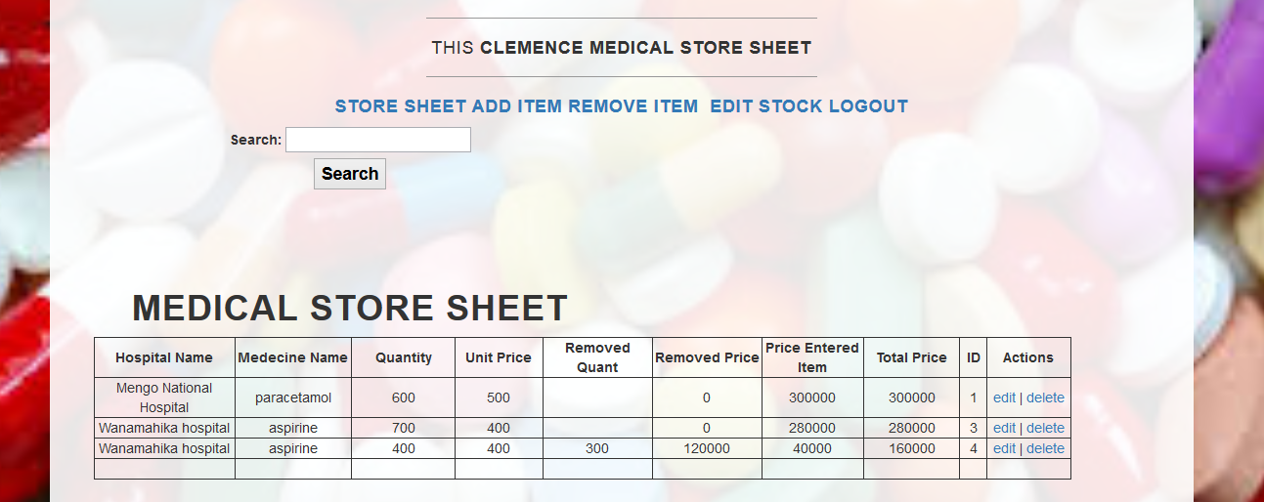

CHALLENGES AND THE BENEFITS

* **BENEFITS**
* Efficiently maintains the details about every transaction about a product in the store
* Simultaneously updates changes made to any data, item in the entire data base.
* It is faster than manual system
* It is fast, efficient and reliable
* Avoids data redundancy and inconsistency
* Very user-friendly
* Easy accessibility of data
* Number of personnel required is considerably less
* Provides more security and integrity to data
* Avoids of loses in the store
* **challenges**
* Lack of immediate retrievals
* Lack of immediate information storage
* Lack of prompt updating
* Preparation of accurate and prompt reports

**Conclusion**

As we have finish this report, it have helped me to make in practice all knowledge I have acquire in the course of PHP during all the semester, because I have done this project myself with the help of some research on Google.

We hope that this system will be useful to someone in this world.

**Merry Charismas and Happy New Year 2016**

**Done and signed by Clemence Patayo**

…………………………………